**(CM1103 Coursework 2016: Report Figures and Captures of the interactive python)**

**Student name: Wisam AhmadYunus Siyamak**

**Student number: 1567957**

**Date: 07/12/2016**

**Project: (Squash Game)**

Capture of the interactive python session:-

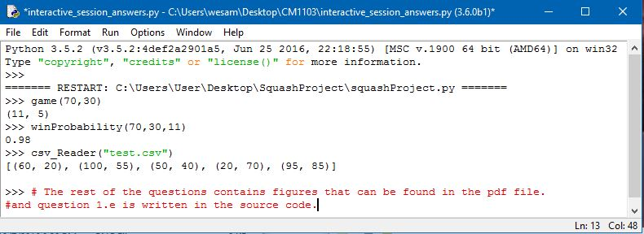

Figure [1]: interactive Python session.

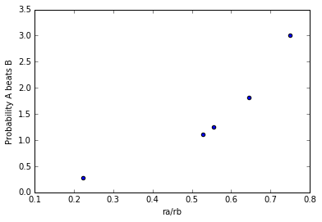**Question 1.d Matplot Figure:**

Figure [2]: matplot(data_list) for question Q1.d

The graph above indicates the test on the function *matplot(data_file)*. The function has been called using the *csv_Reader(“test.csv”)* as an argument from question Q1.c (Check the code source). As the graph shows the blue dots that represents the probability of *A* winning a game against *B* along with the *ra/rb* axis.

**Question 2 Matplot Figure:**

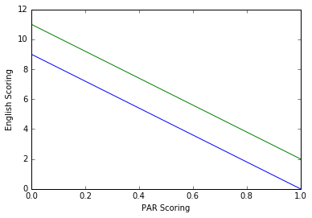

Figure [4]: EnglishVsPars() for question Q2.

The figure above represents the blue line for the English and green line for the Pars rule. From the graph we can say that the Pars takes less time than the English scoring since the rules requires for the returner player to win the rally to get the server and then be able to score a point; the chances of having more rallies would be on the English scoring. Regardless of the final points (11 for Pars) or (9, 10 for English), the probability of scoring a point decreases in the English. For instance if we check the rallies counter variable (*countrallies*) in the source code; the number of rallies are always higher in the English matches than the PARS ones.